
FATIMA JINNAH WOMEN UNIVERSITY
RAWALPINDI
Department Of Software Engineering

Cloud Computing Lab
Saira Ejaz [2023-BSE-057]
Section: 5-B
LAB NO 8

AWS: Account Setup, IAM, VPC Inventory, EC2, Docker & Gitea
Lab Tasks:

Task 1 — Create an AWS account and enable UAE (me-central-1)
- Open your browser and go to: AWS Signup
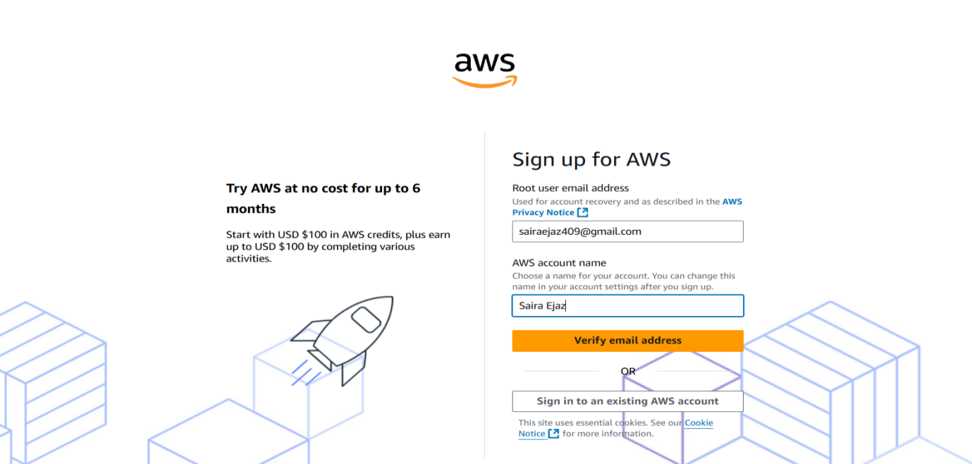
- Complete registration (Account type: Personal, Plan: AWS Paid Plan), fill contact, billing (credit card) and phone details, complete verification. After successful registration capture:
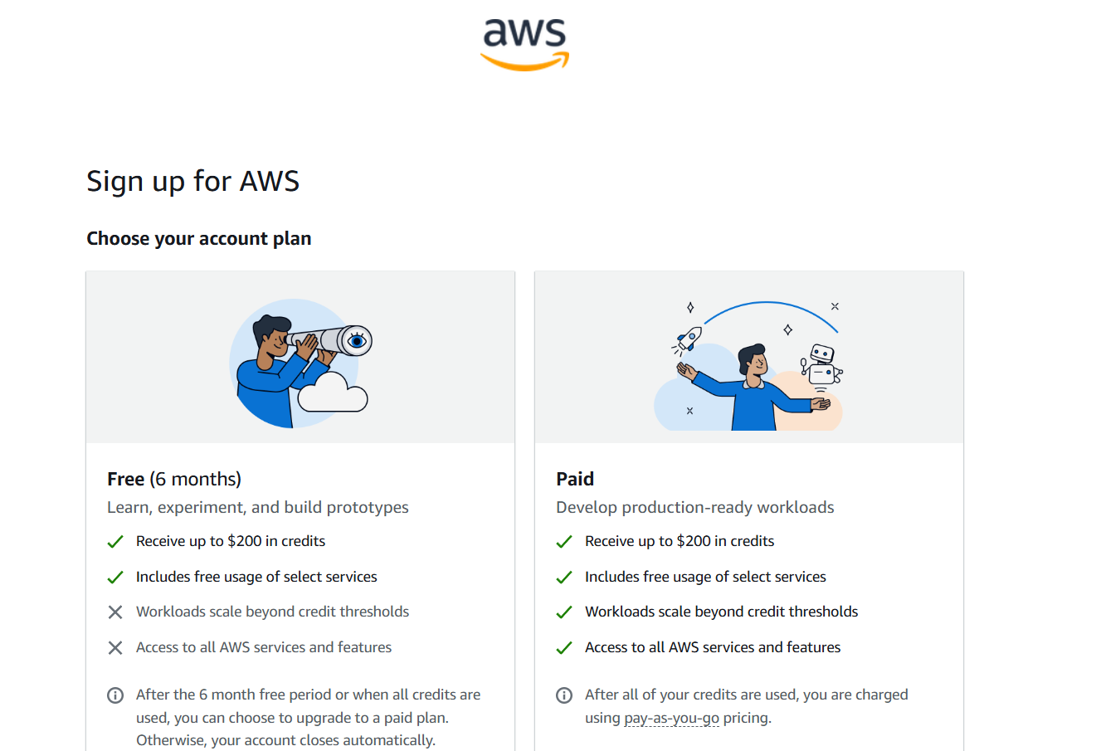
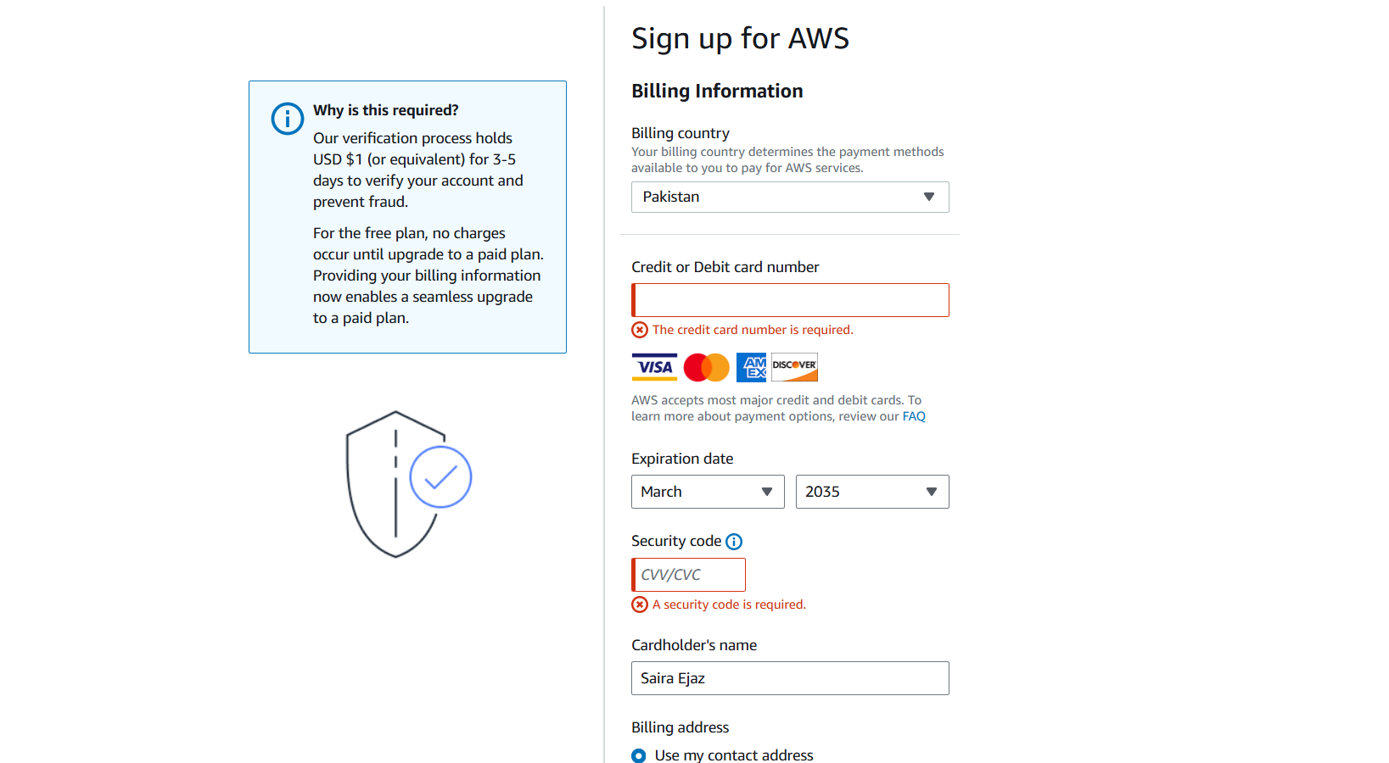
- Sign in as the root user (root email). Immediately capture:
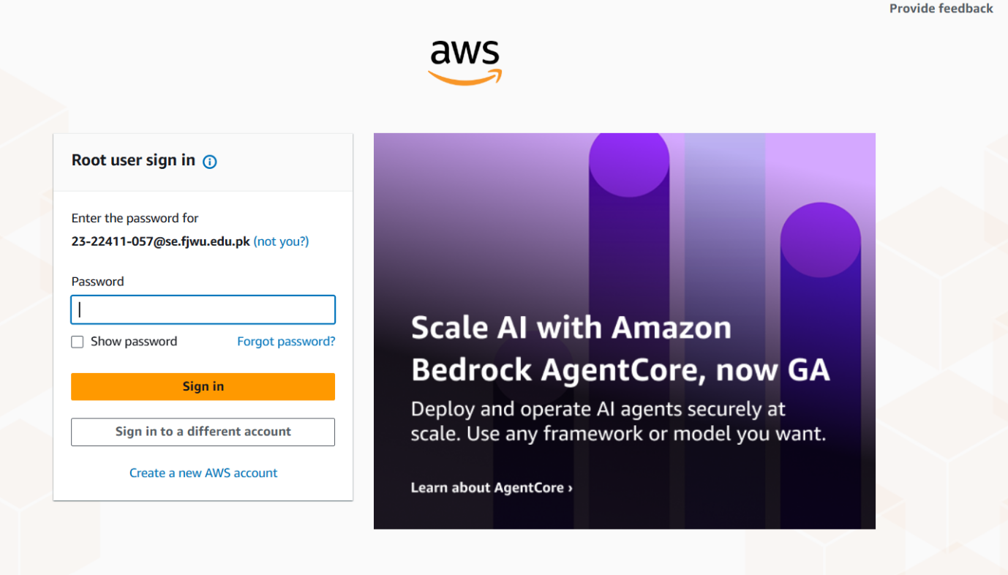
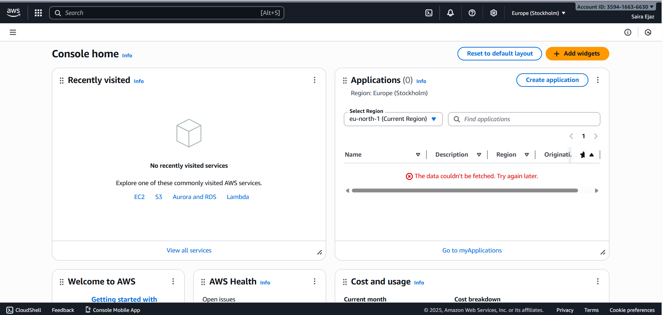
- From the Console, open the region selector and enable UAE (me-central-1), then switch to me-central-1. Capture the change:
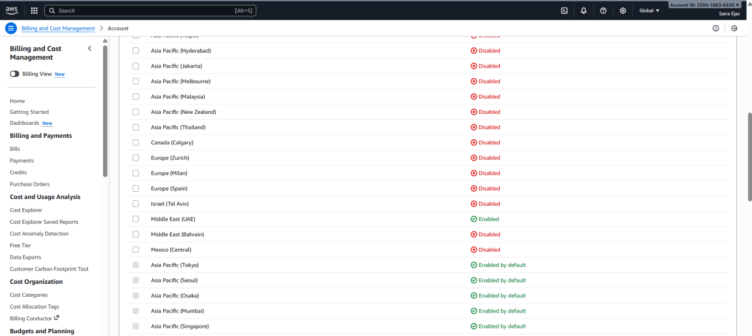
- Task 1 summary screenshot (combine evidence):

Task 2 — Create IAM Admin and Lab8User with console access
Goal: Create an IAM user named Admin (console access + Administrator Access policy), download the .csv, logout root, then login as the IAM Admin and create Lab8User with same permissions.
- Open IAM via Console search (Alt+S → "IAM").
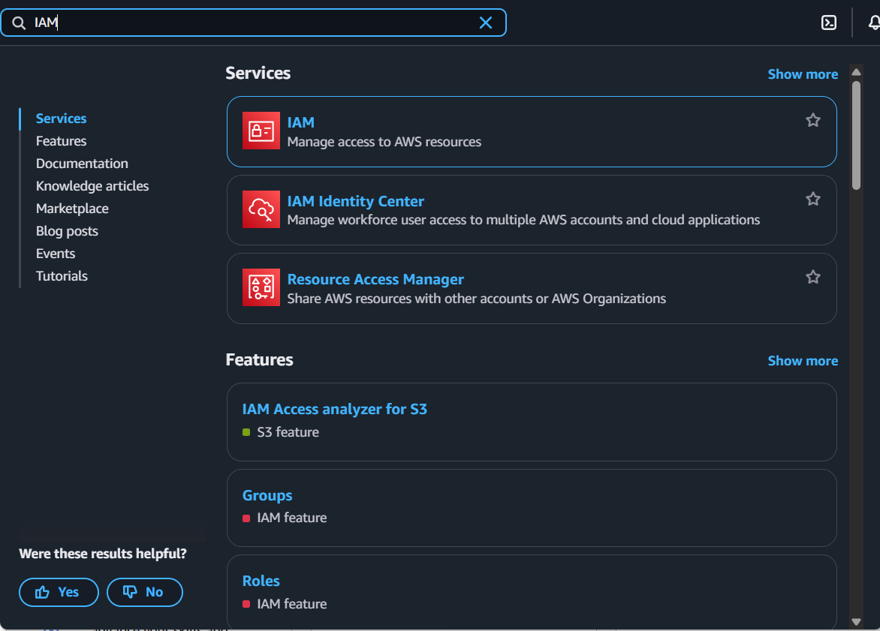
- Create the Admin user: IAM → Users → Create user. Fill:
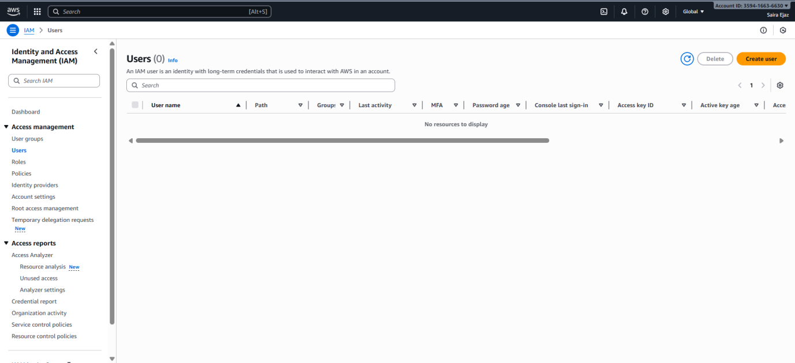
- Username: Admin
- Provide user access to the AWS Management Console
- Set console password (autogenerate or set)
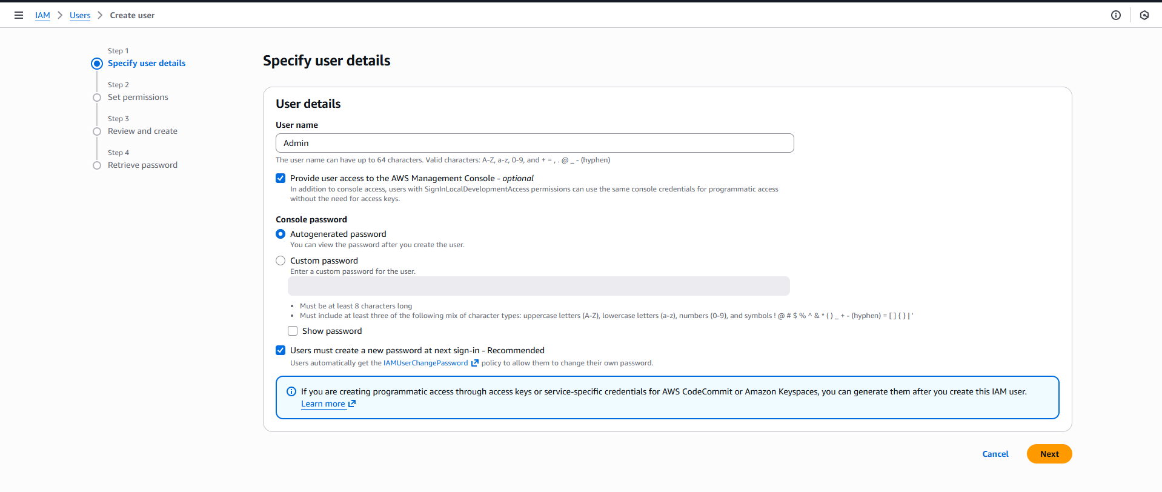
- Attach policies directly → AdministratorAccess
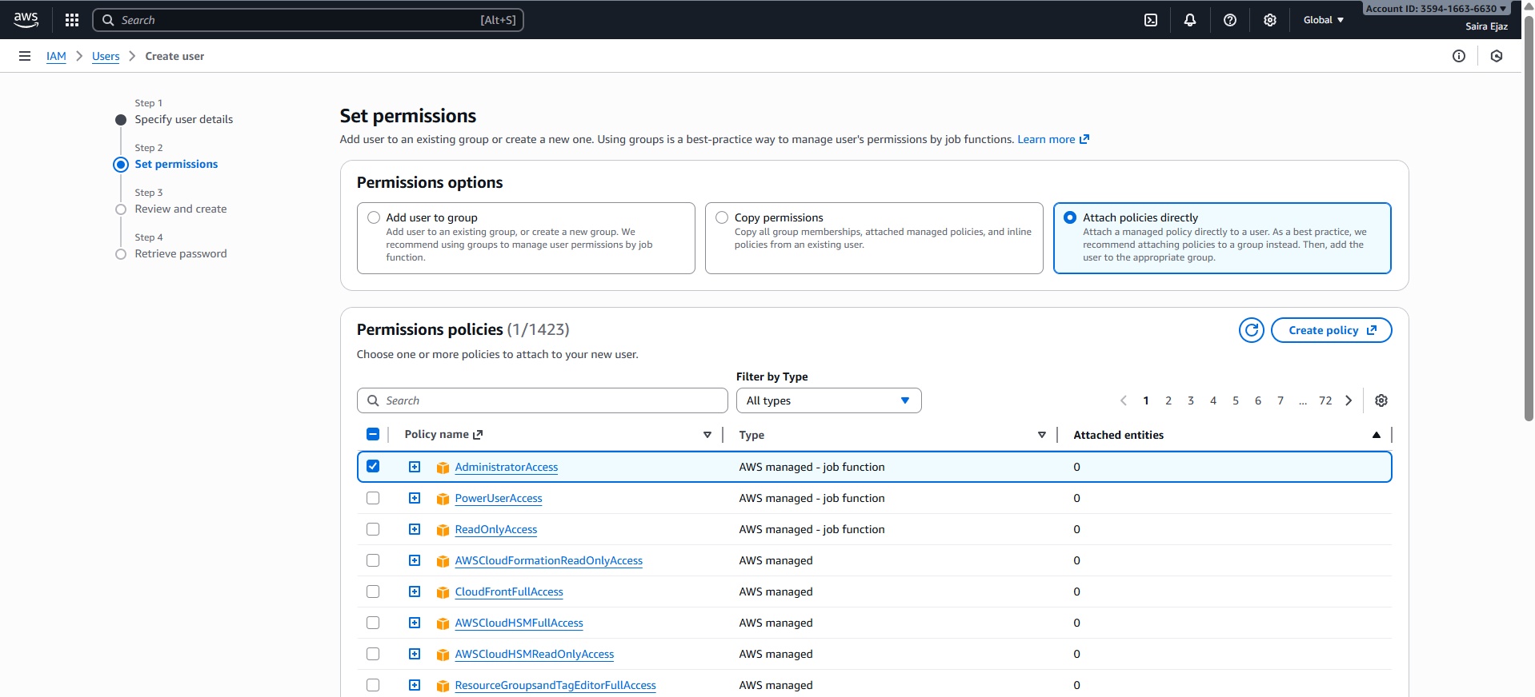
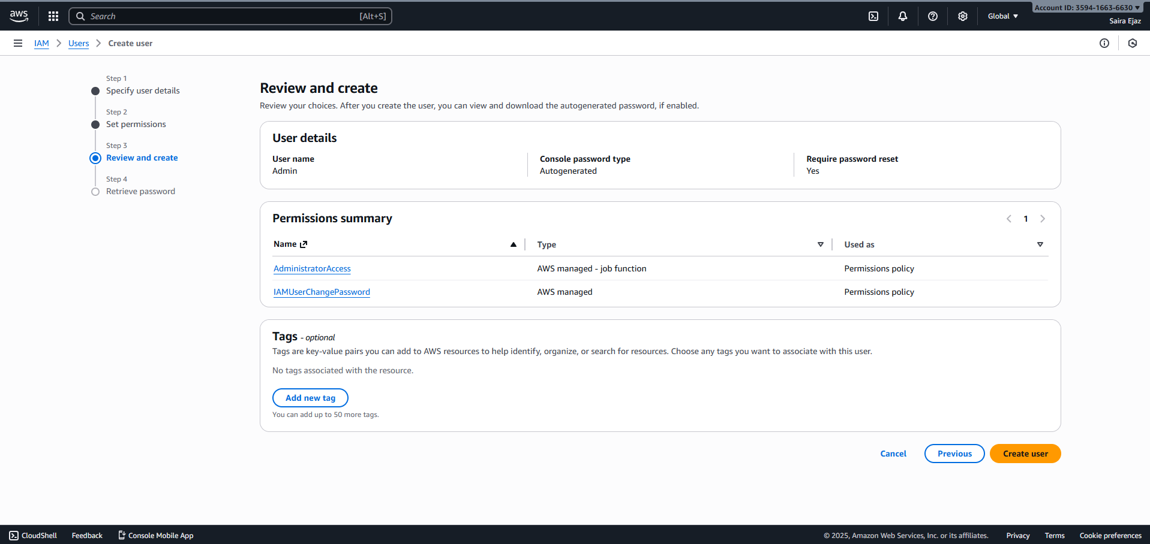
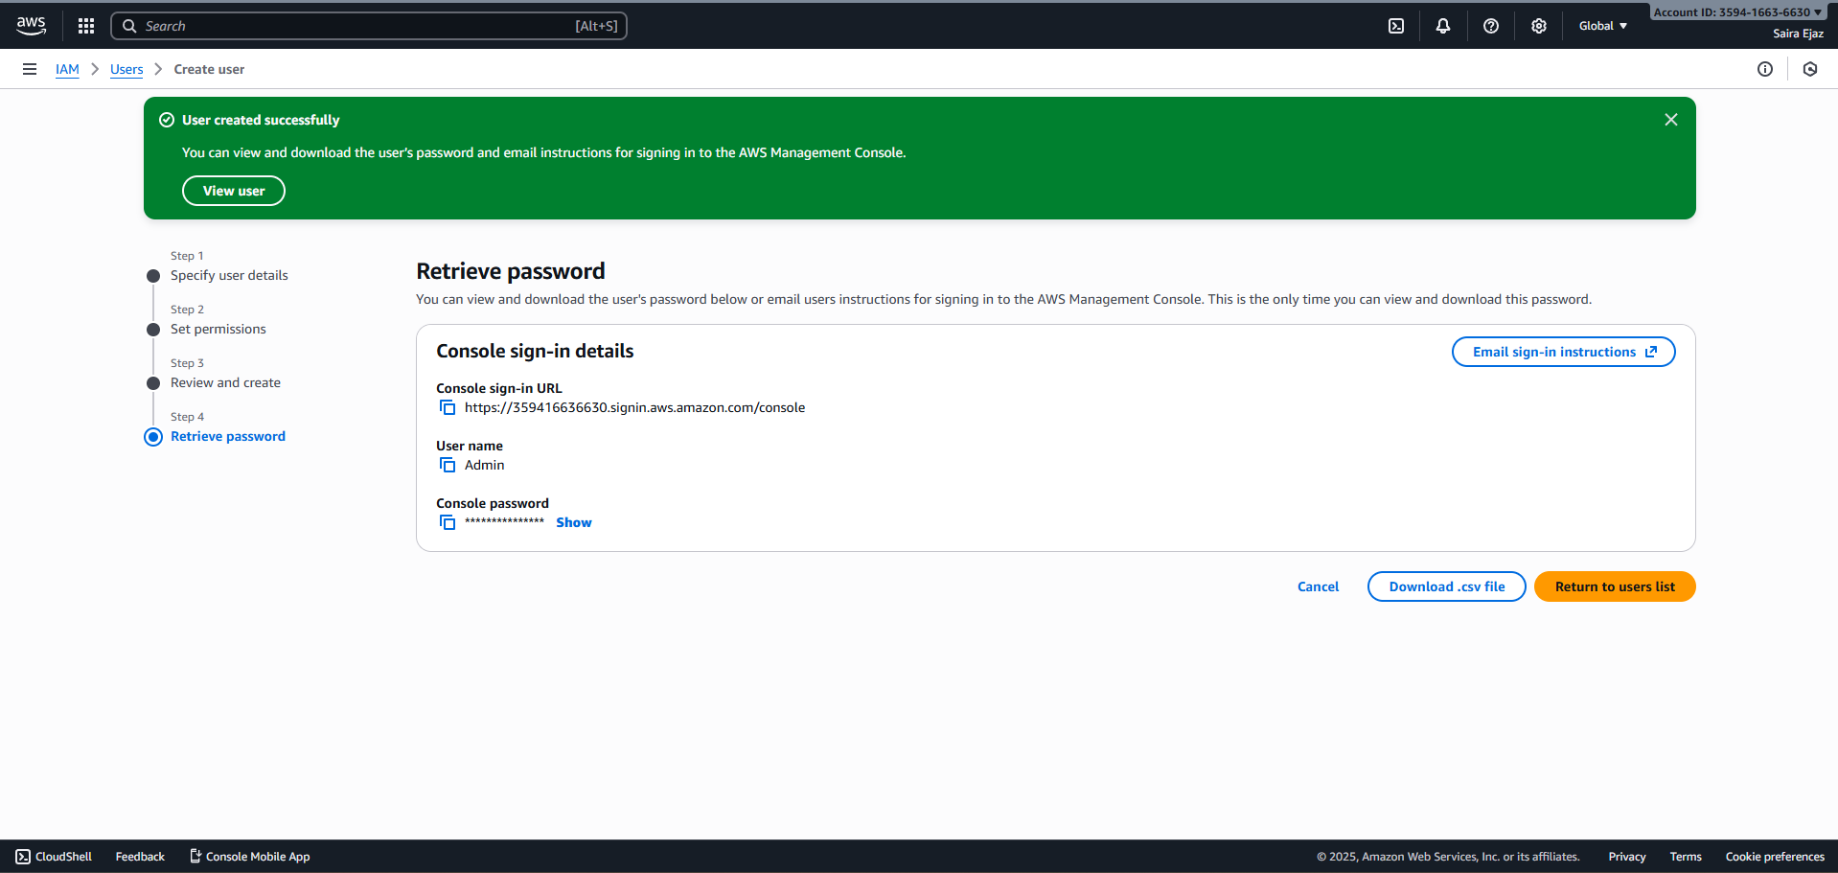
- Download the Admin .csv and show its presence on your Windows host (do not display the password text):
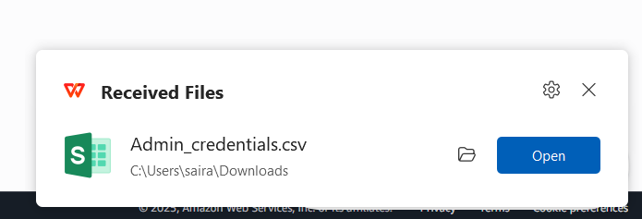
- Sign out of root, then sign in using the Admin account (use the sign in URL from the .csv). Capture after successful Admin login:
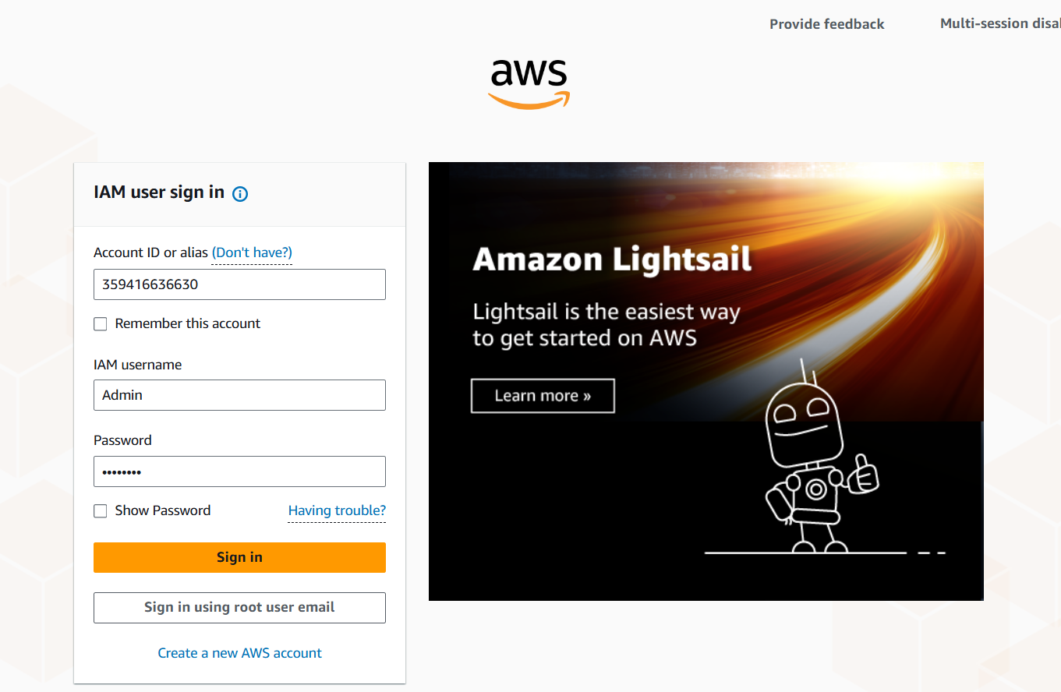
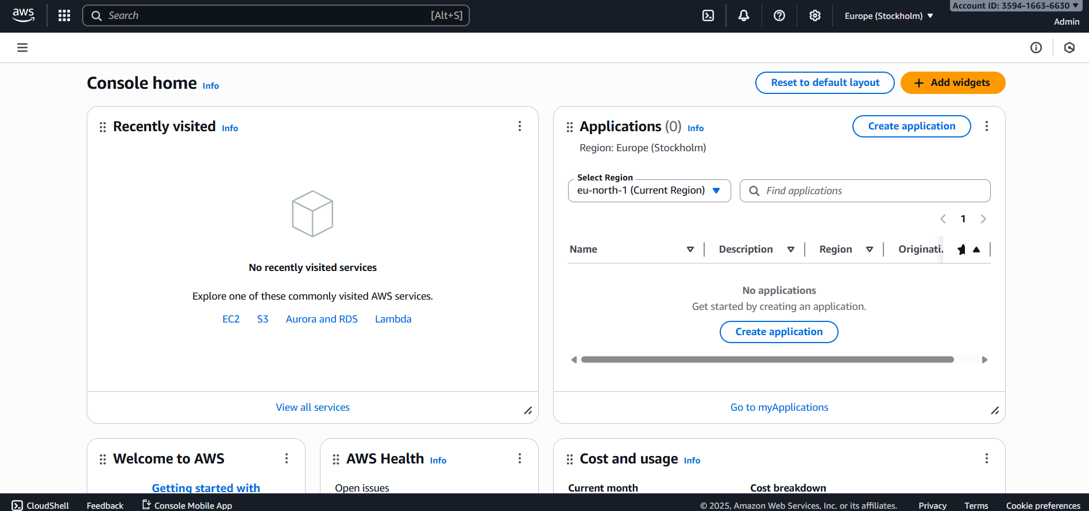
While logged in as Admin, create Lab8User:
- IAM → Users → Create user
- Username: Lab8User
- Provide user access to the AWS Management Console
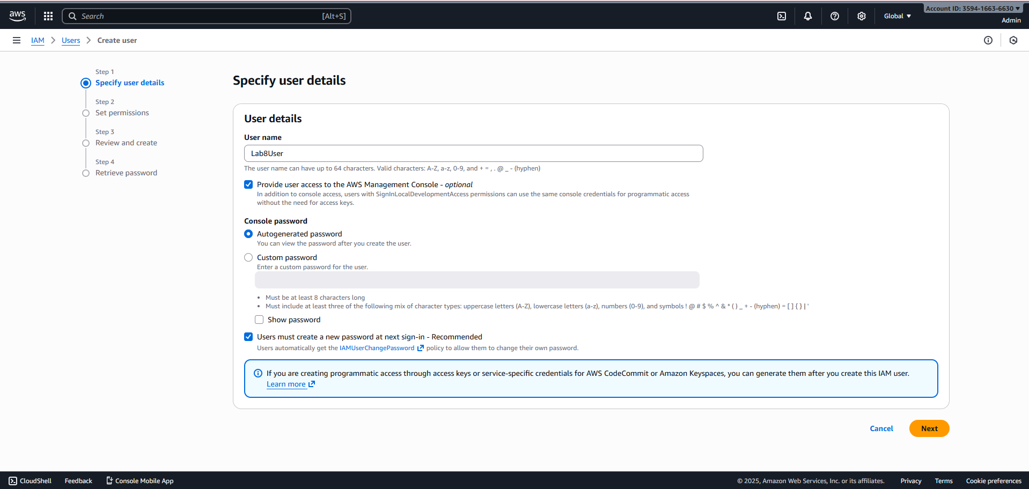
- Attach AdministratorAccess policy
Capture the create-user success screen:
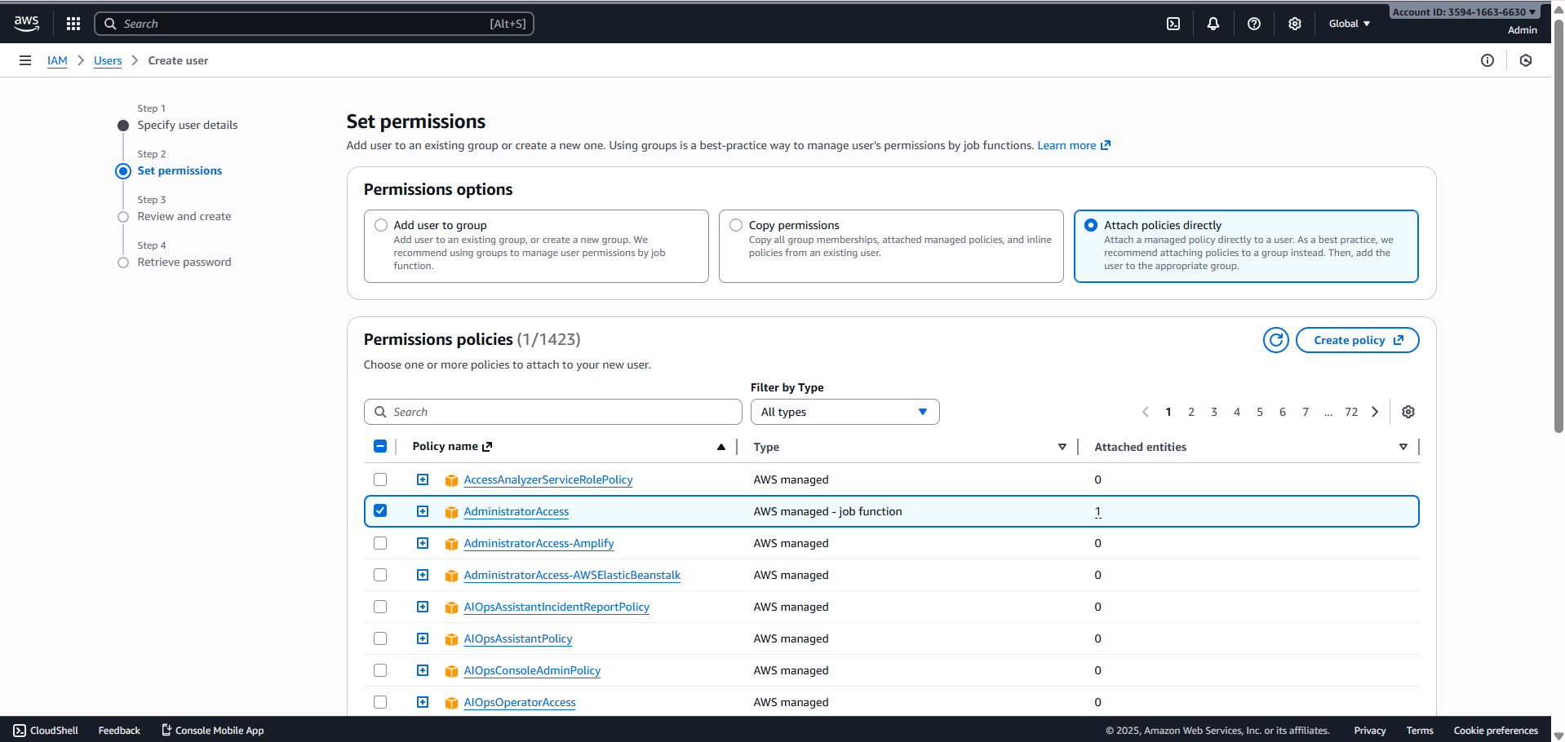
- Download/save the Lab8User CSV on your Windows host (do not show password).
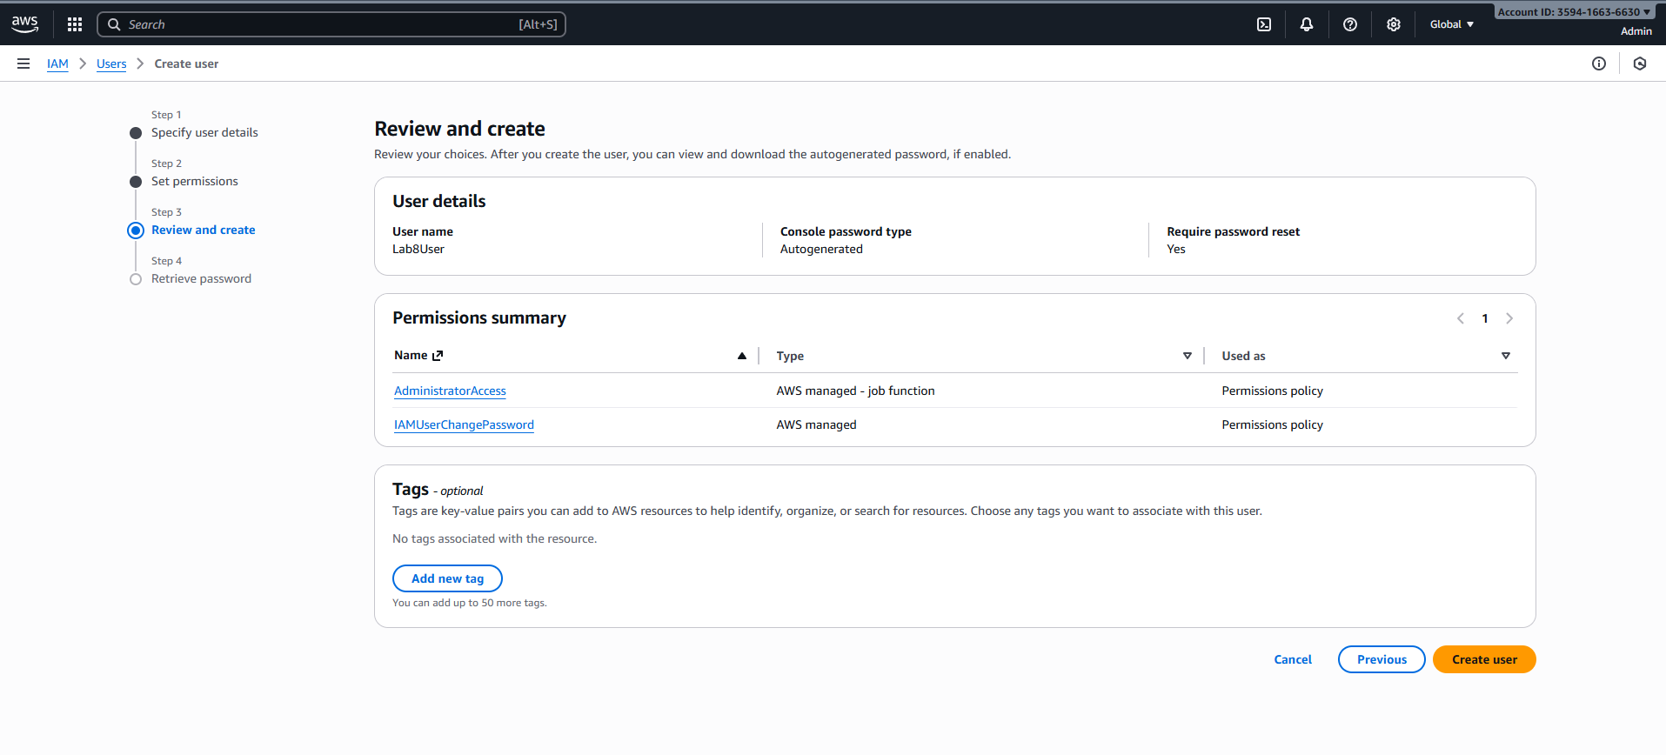
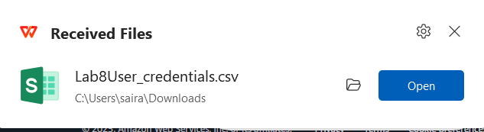
- Logout Admin and login as Lab8User (use the Lab8User signin URL and credentials). Capture after login:
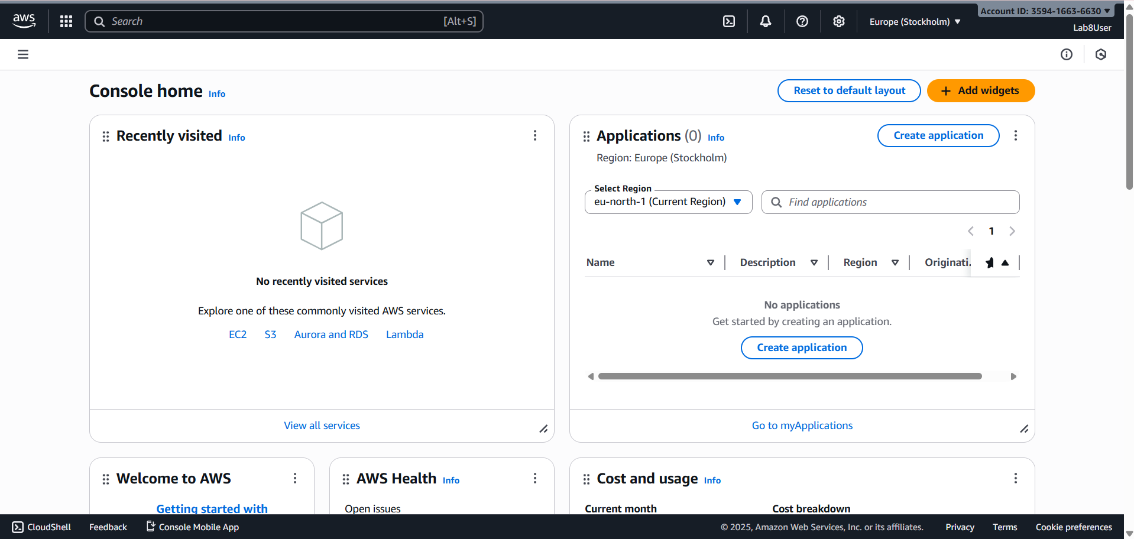
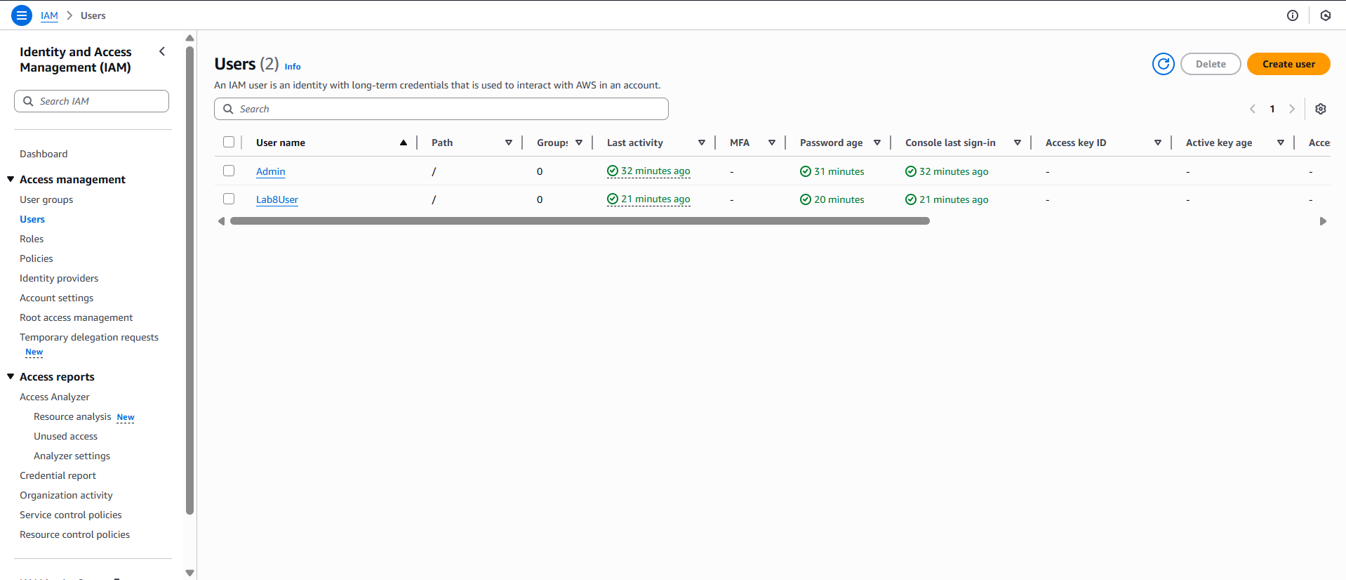

Task 3 — Inspect VPC resources (in UAE me-central-1)
Goal: In the VPC console list the counts of specific resources.
- Open VPC console (Alt+S → "VPC") while region is me-central-1.
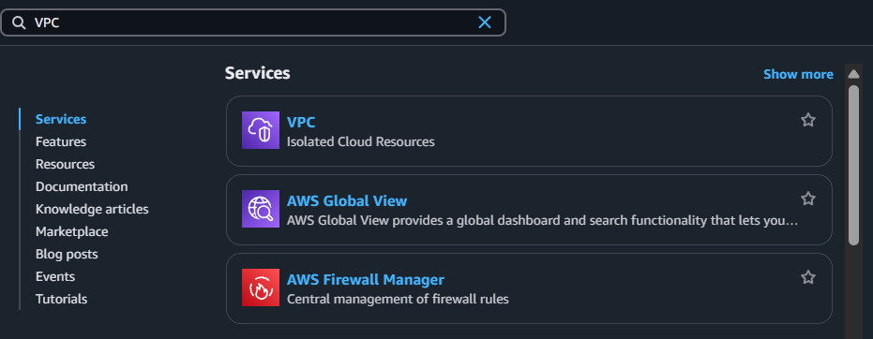
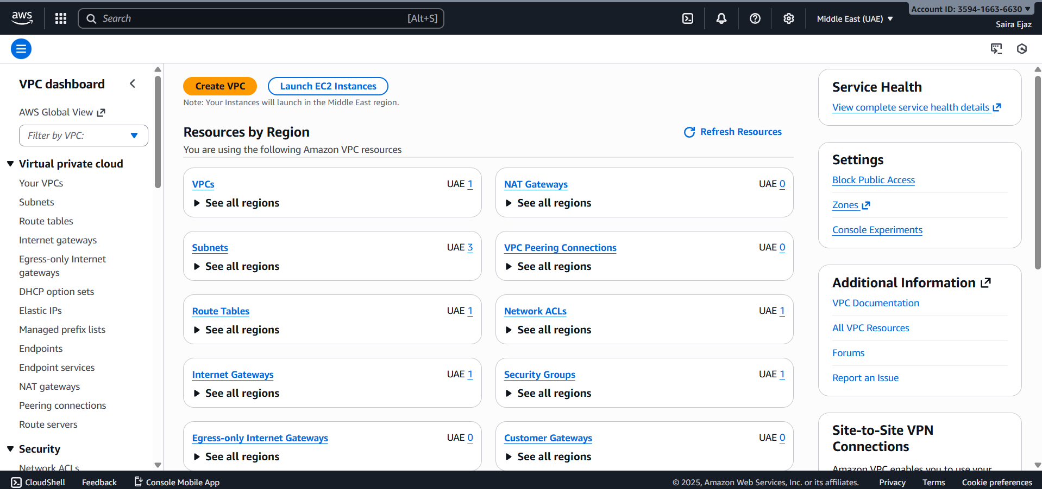
- View VPCs list. Capture:
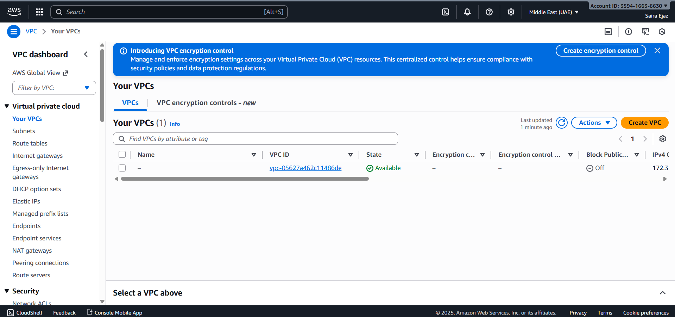
- View Subnets list. Capture:
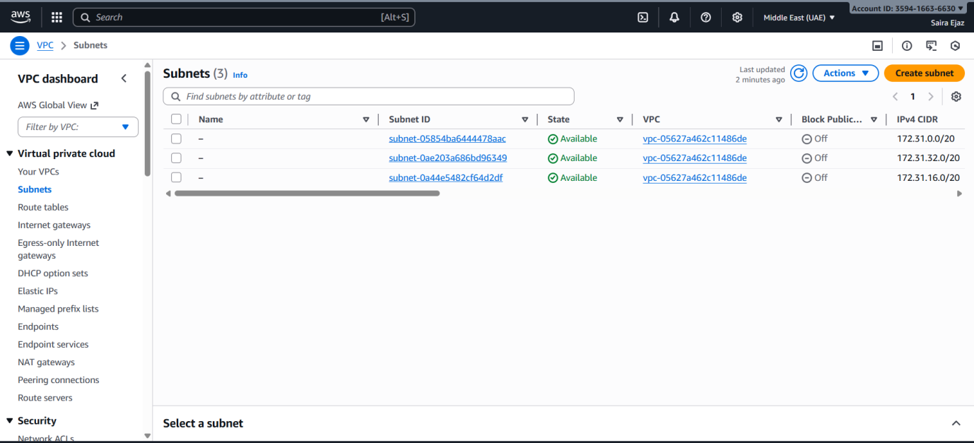
- View Route Tables list. Capture:
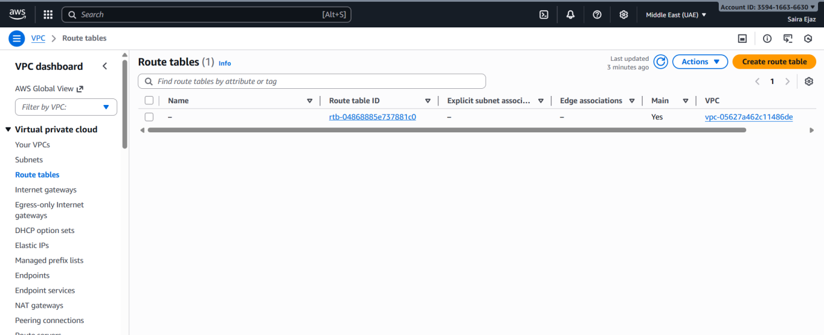
- View Network ACLs list. Capture:
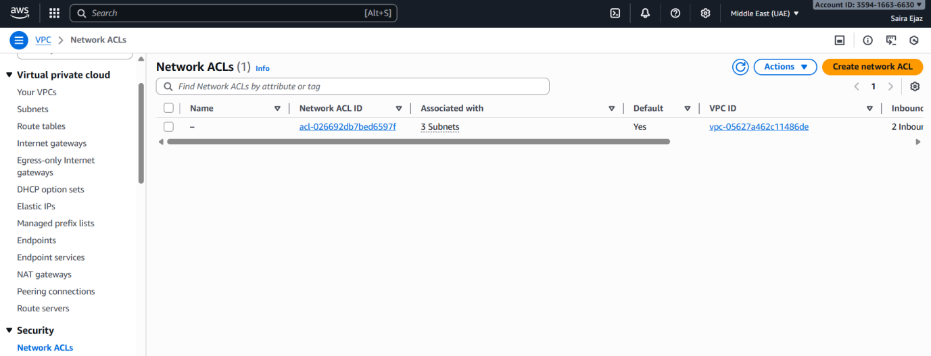
- Task 3 summary (combine evidence):
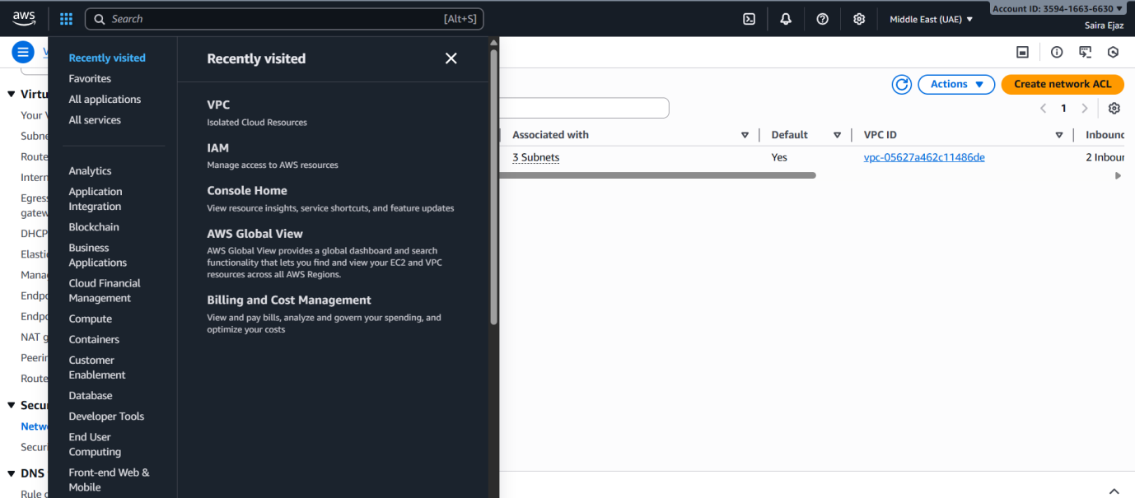

Task 4 — Launch EC2, SSH, install Docker & Docker Compose, deploy Gitea

Goal: Launch an EC2 instance named Lab8Machine, configure security group Lab8SecurityGroup allowing SSH from your IP, create an ED25519 key pair Lab8Key (.pem), SSH from Windows host, install Docker & Docker Compose, create compose.yaml from the repository, run docker compose up -d, allow inbound TCP port 3000, and open Gitea UI.
- Open EC2 Console (Alt+S → "EC2") (me-central-1).
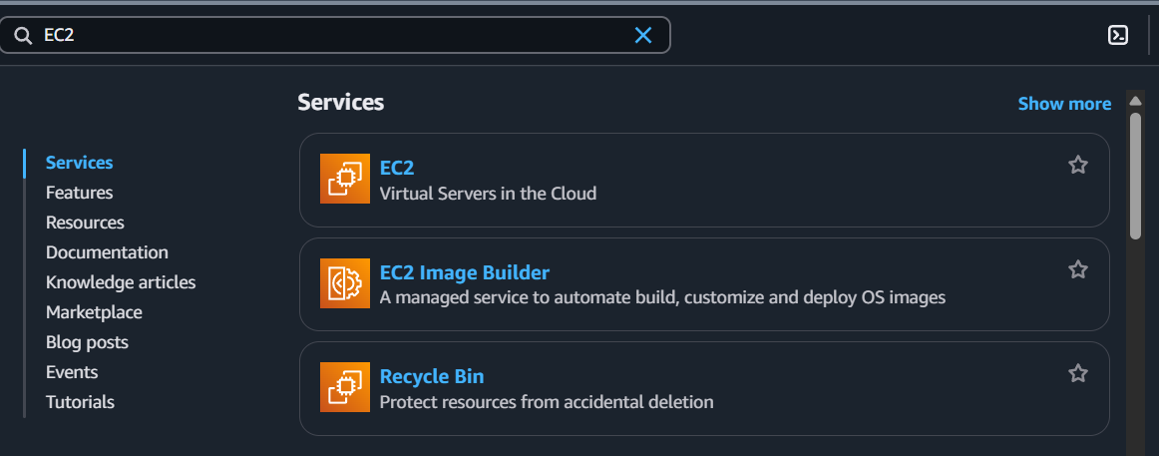
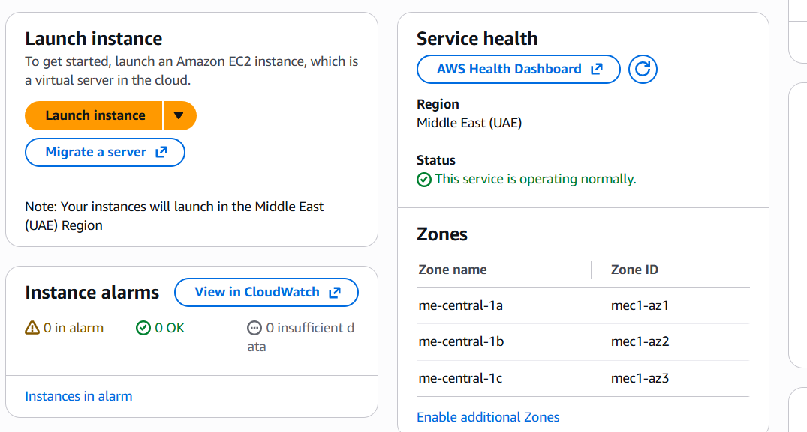
- Instance Launch configuration (during review before launching). Configure:
- Name: Lab8Machine
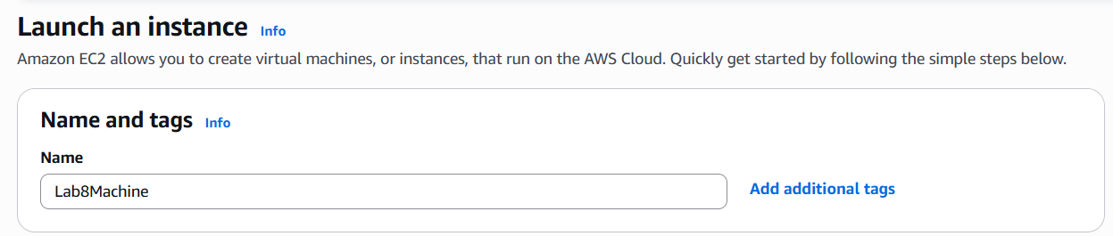
- AMI: Amazon Linux 2
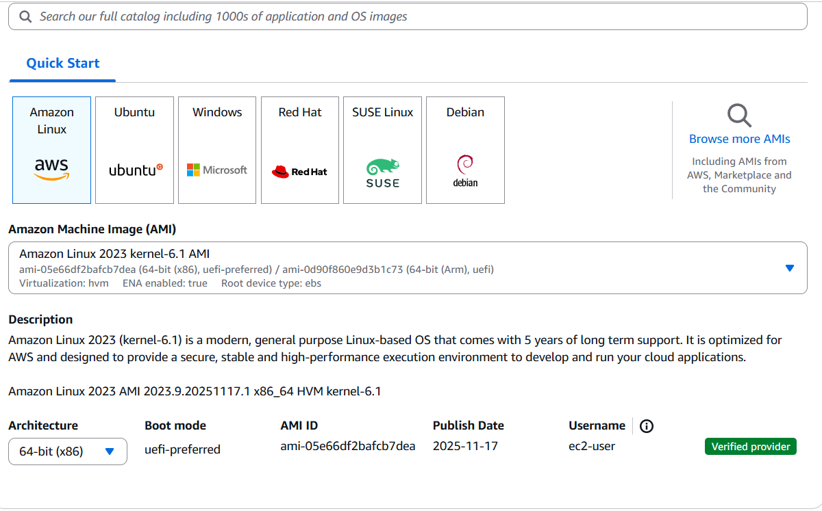
- Instance type: t2.micro
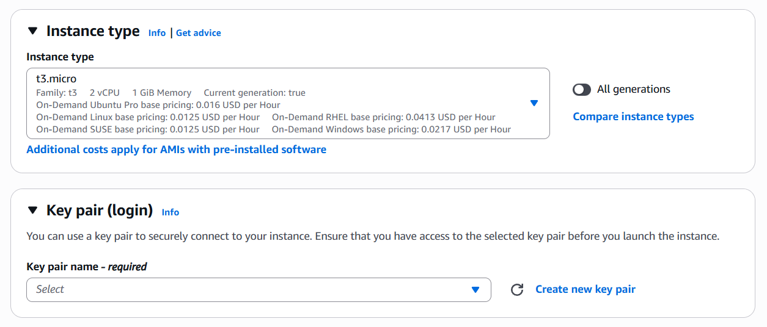
- Security group: Create Lab8SecurityGroup with SSH from My IP
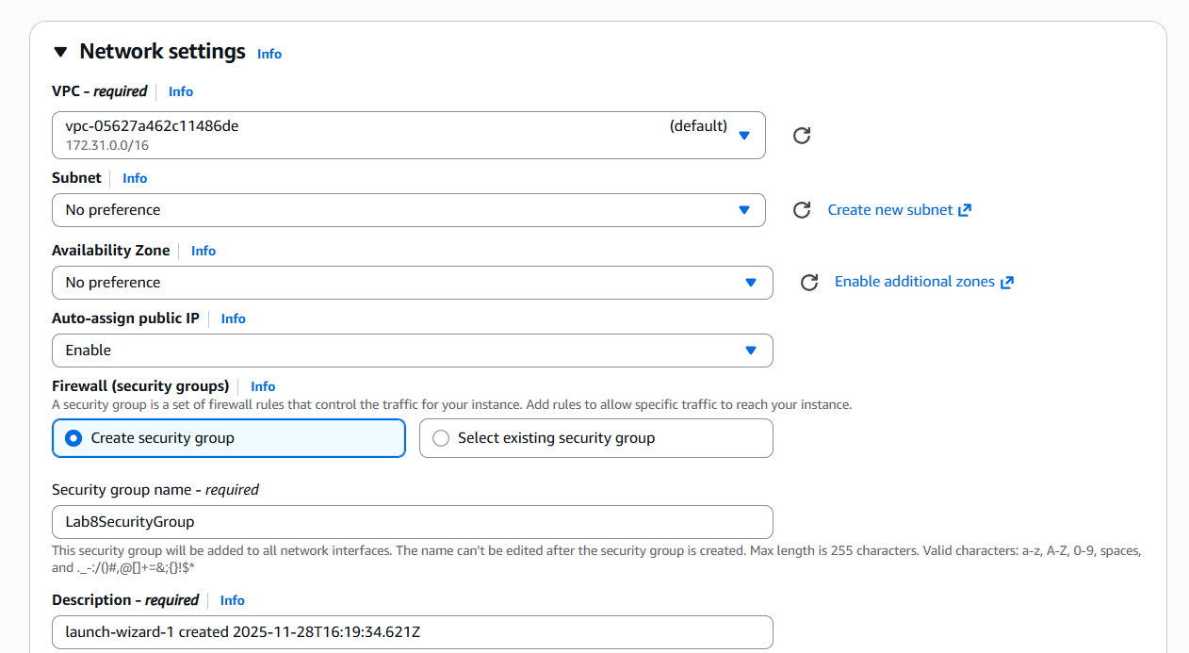
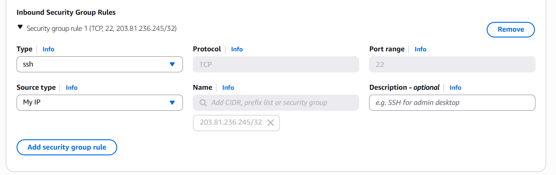
- Storage: default
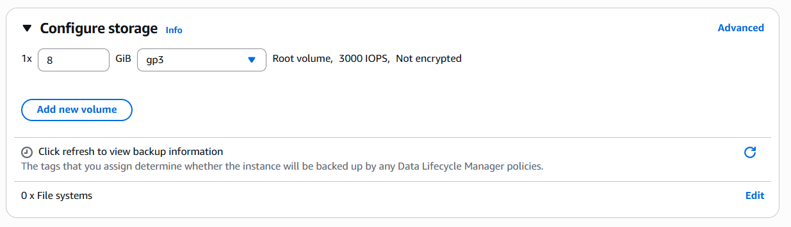
- Key pair: Create Lab8Key (ED25519, .pem) and download the .pem file to your Windows host
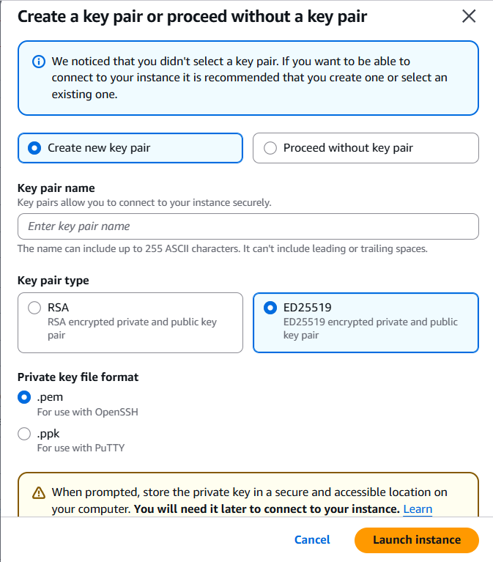
- After launch, EC2 Instances list showing Lab8Machine in "running" state and public IPv4 visible.
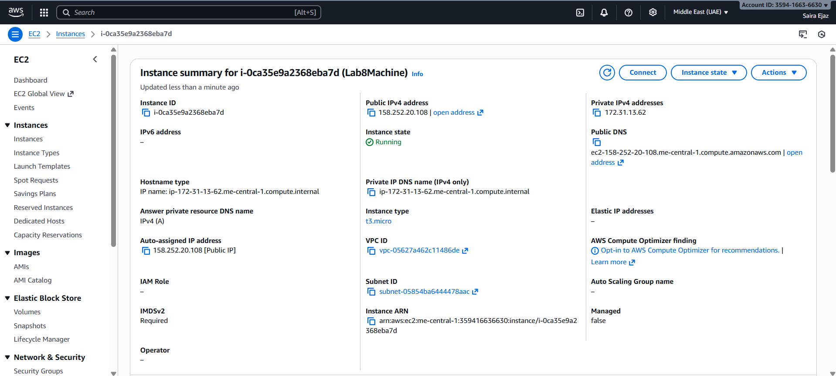
- On Windows host, run SSH using the downloaded .pem (PowerShell/Git Bash/Windows Terminal):
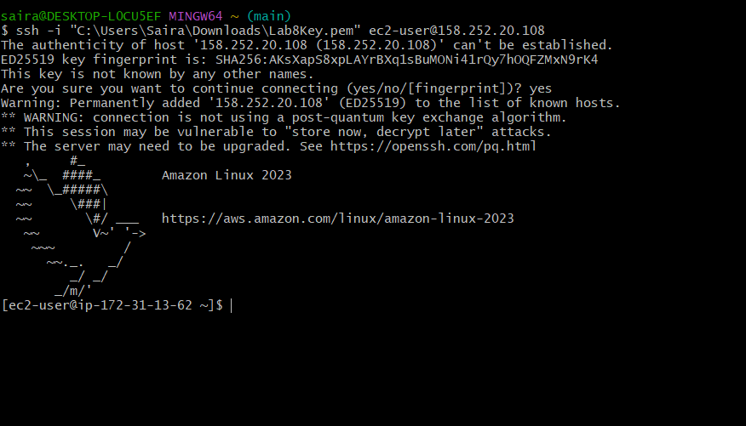
- Run the install commands on the EC2 shell:
sudo yum update -y
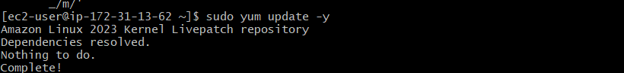
sudo yum install -y docker
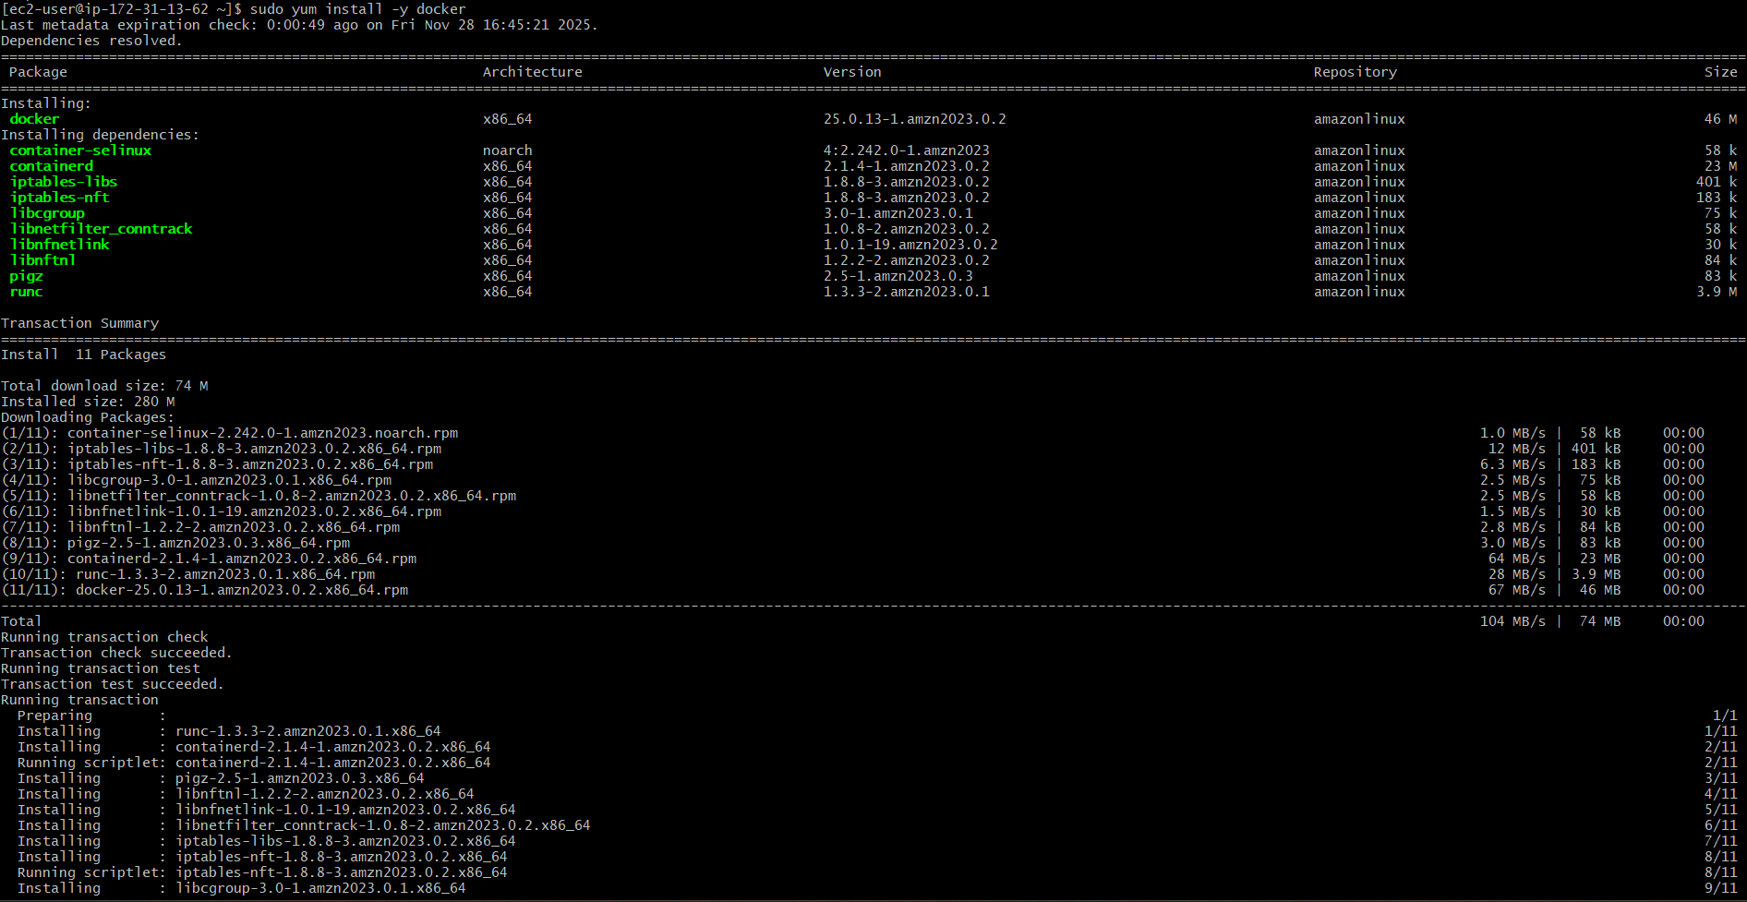
sudo mkdir -p /usr/local/lib/docker/cli-plugins
sudo curl -SL https://github.com/docker/compose/releases/latest/download/docker-compose-linux-x86_64 -o /usr/local/lib/docker/cli-plugins/docker-compose
sudo chmod +x /usr/local/lib/docker/cli-plugins/docker-compose
sudo systemctl start docker
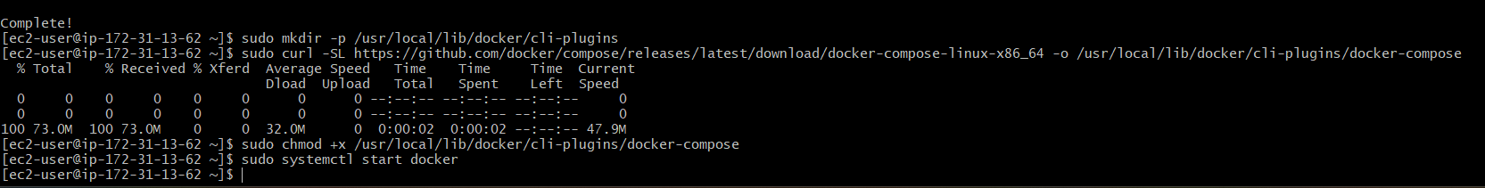
- Create/edit compose.yaml on the EC2 instance (sudo vim compose.yaml) and paste content from the repo: Gitea . While pasting, capture the editor content:
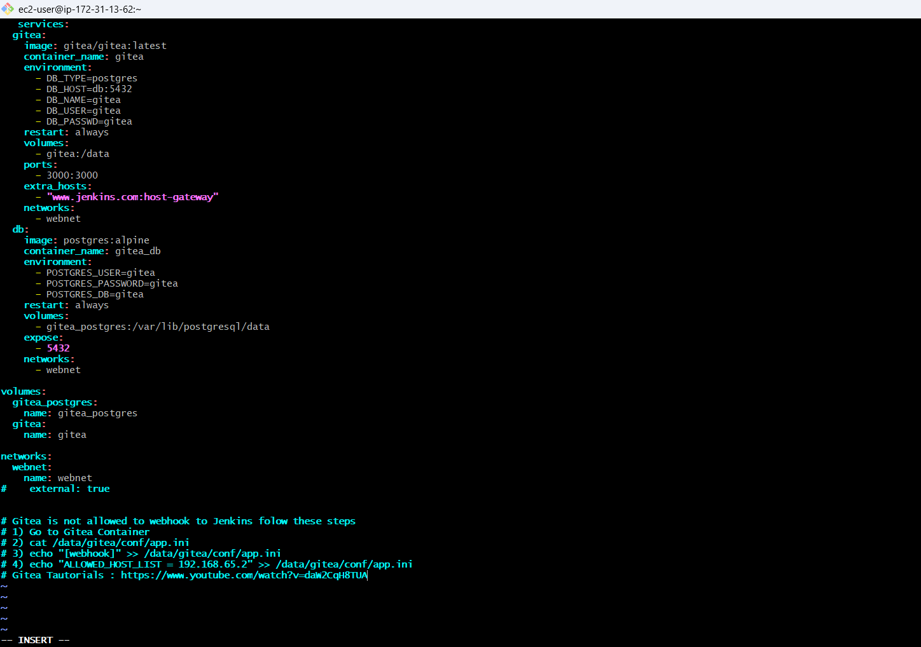
- Save and verify file exists:
- Add ec2-user to docker group, show groups before re-login, exit and reconnect, show groups after reconnect:
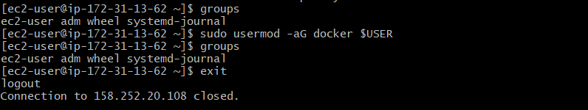
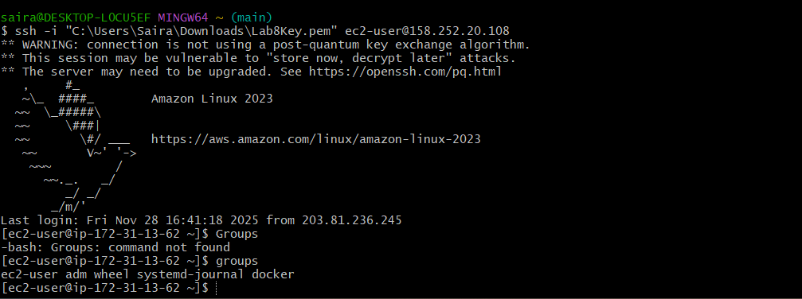
- Run docker compose up -d from the directory with compose.yaml:
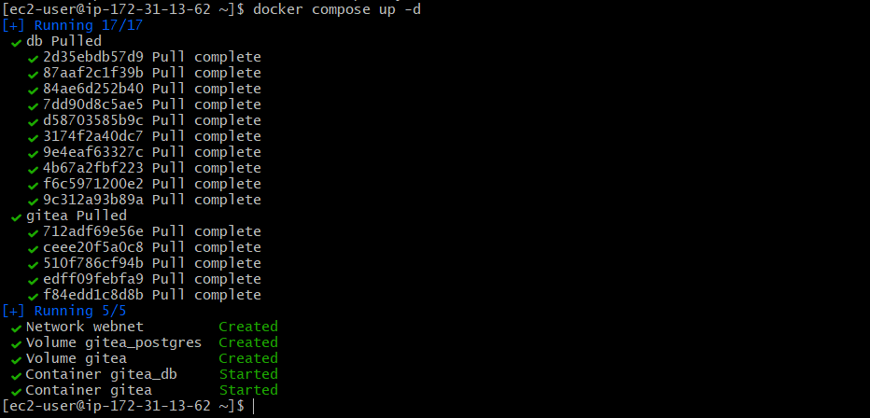
- Edit the security group Lab8SecurityGroup inbound rules in the EC2 console: add Custom TCP rule port 3000 source 0.0.0.0/0 and save. Capture the inbound rules after saving:
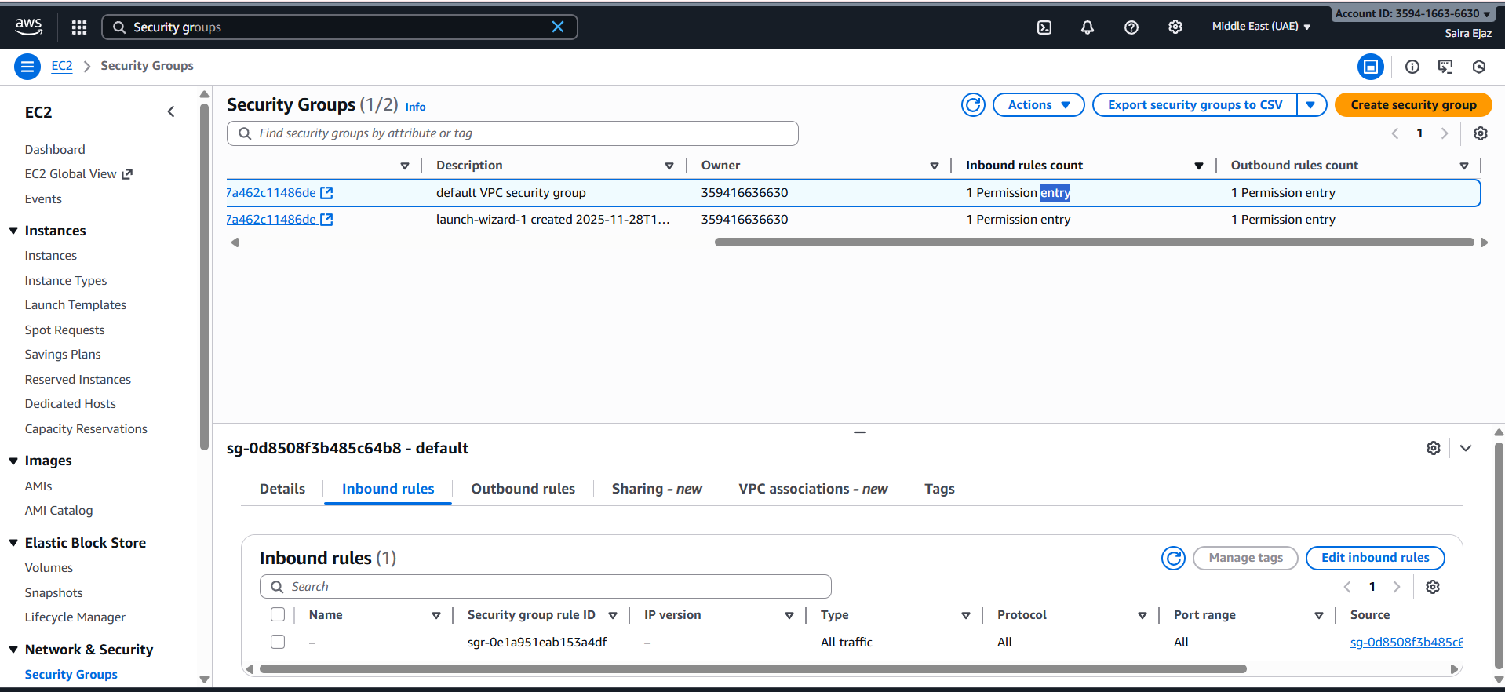
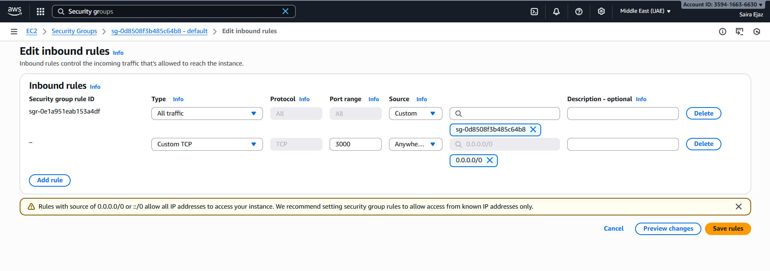
- From your Windows browser navigate to: http://Public-IP:3000 — capture the Gitea setup/install page:
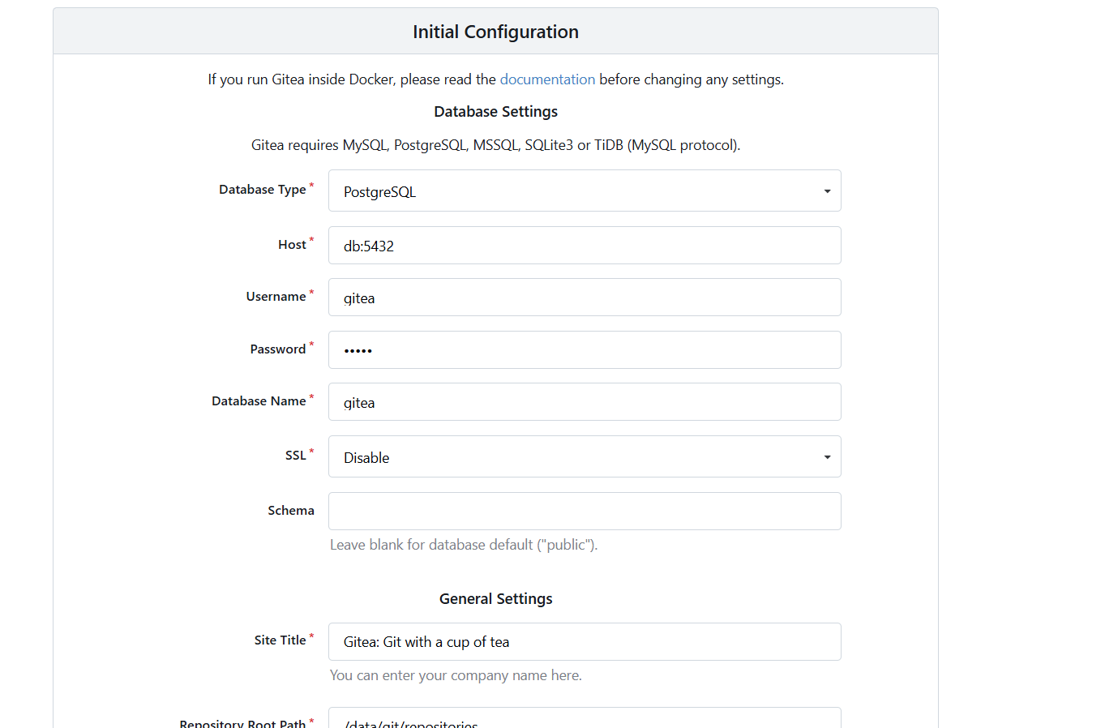
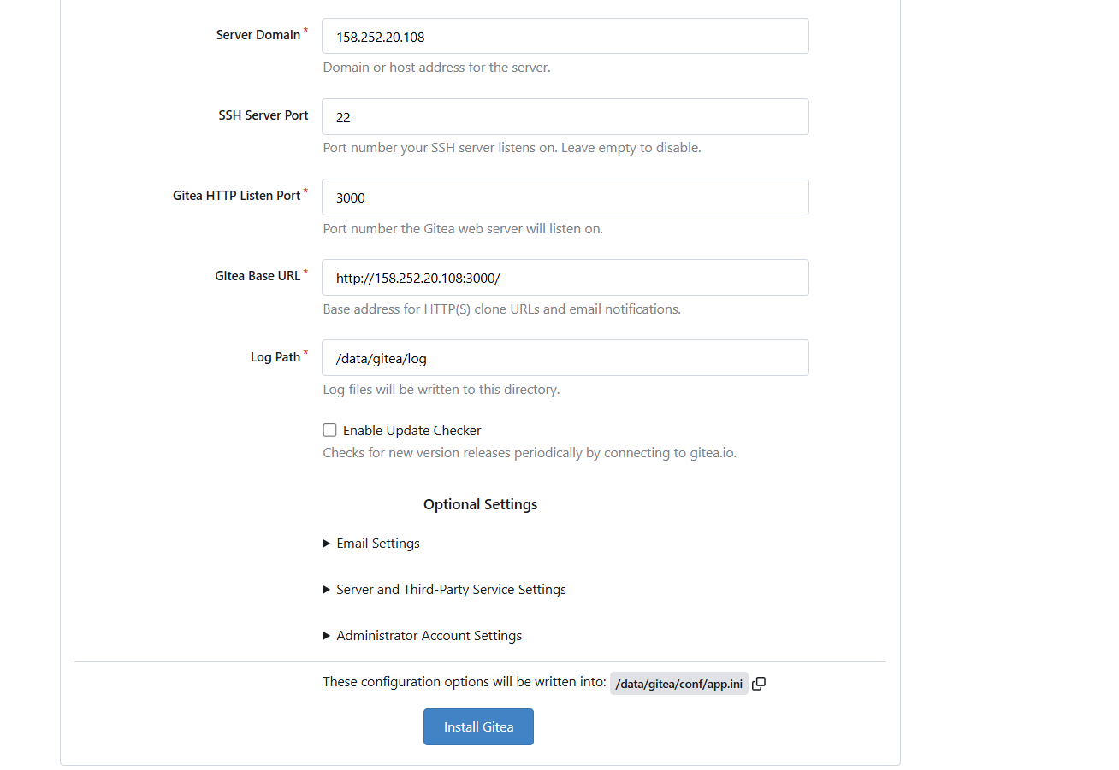
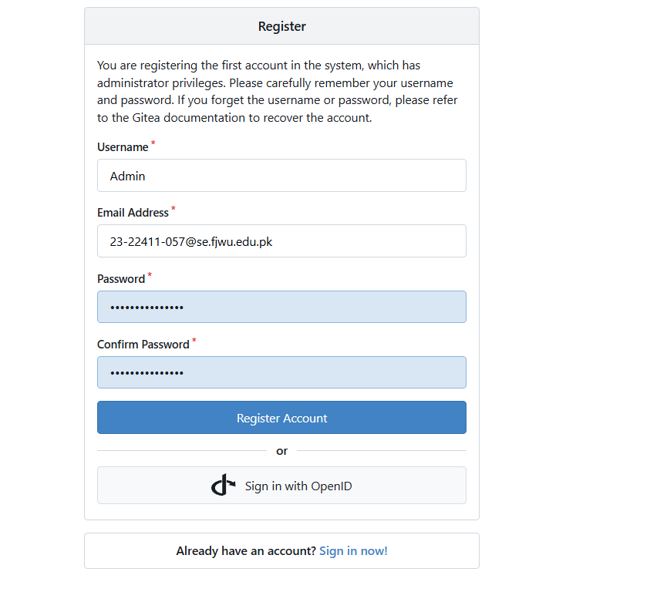
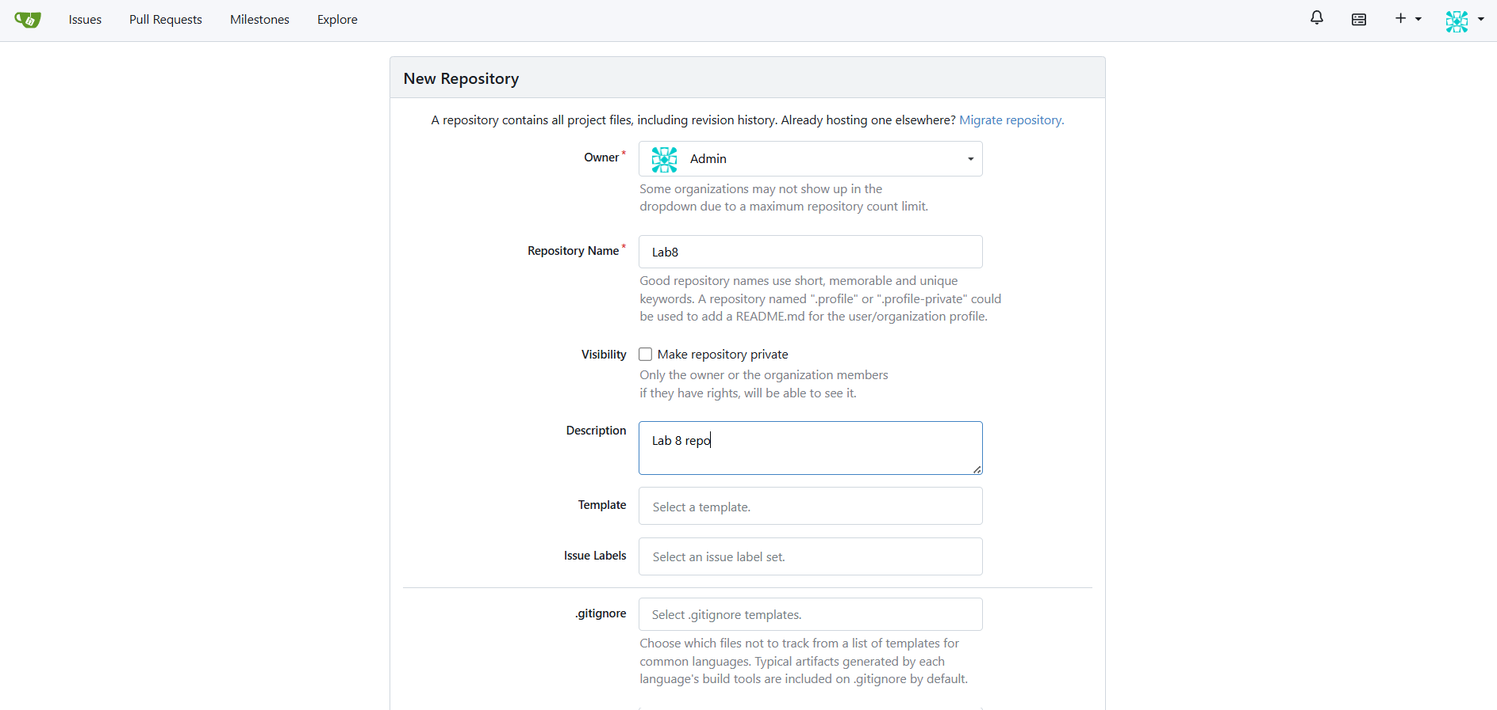
- Task 4 summary (combine evidence)
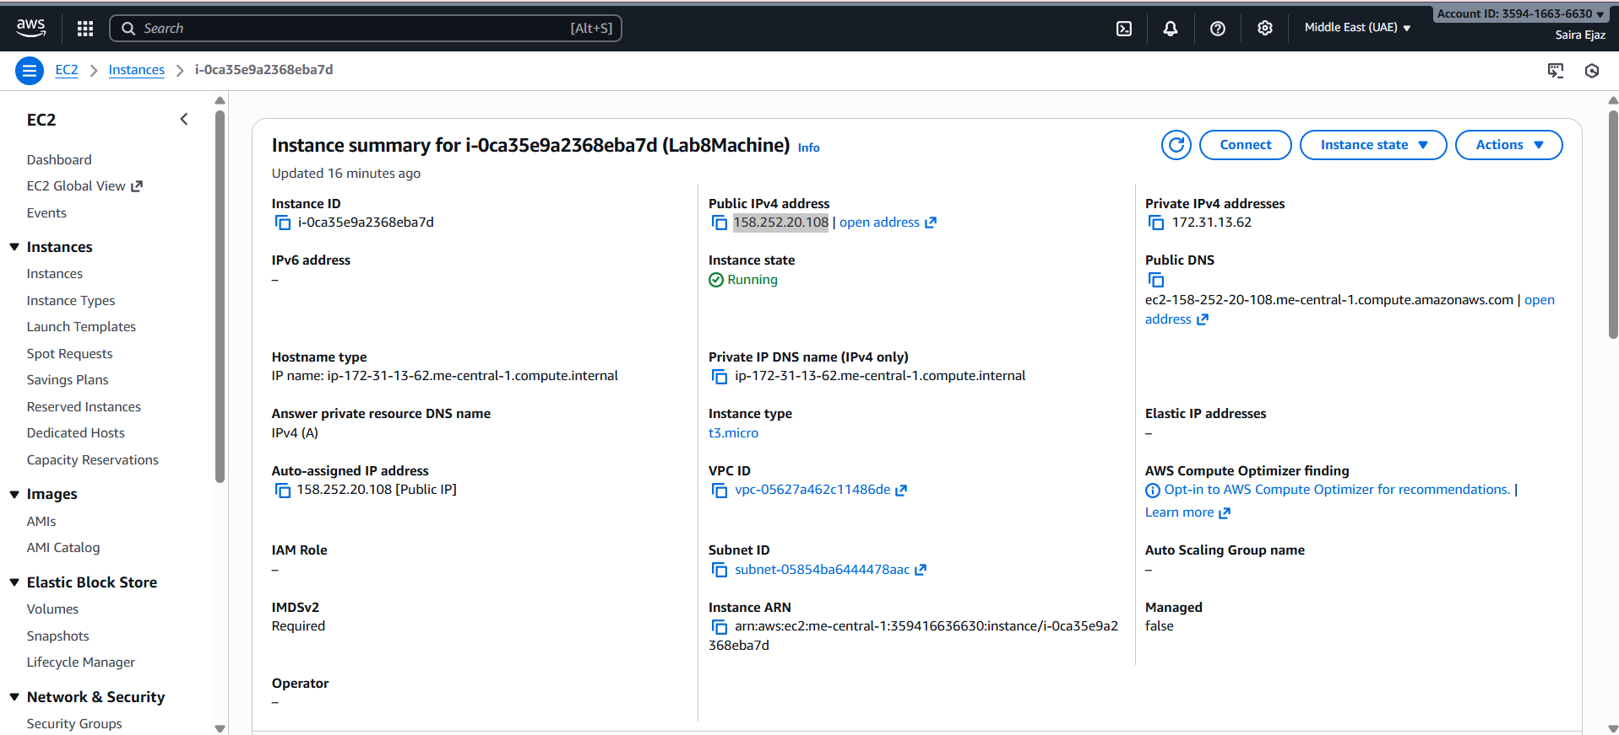
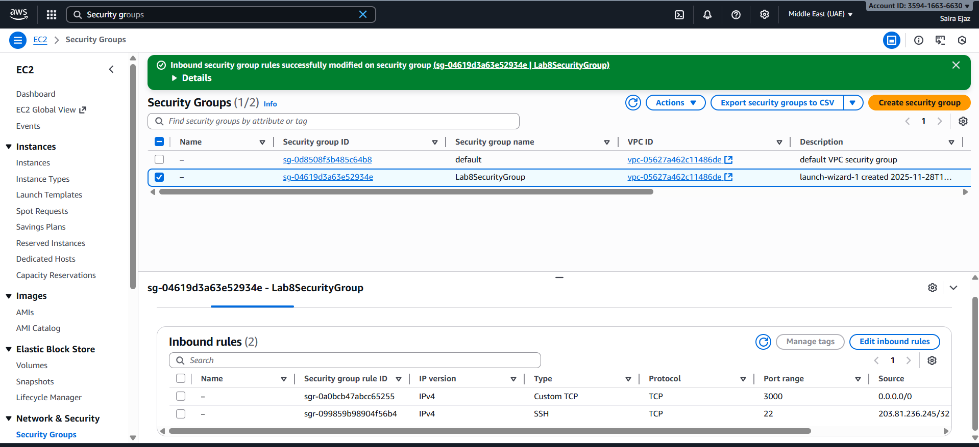
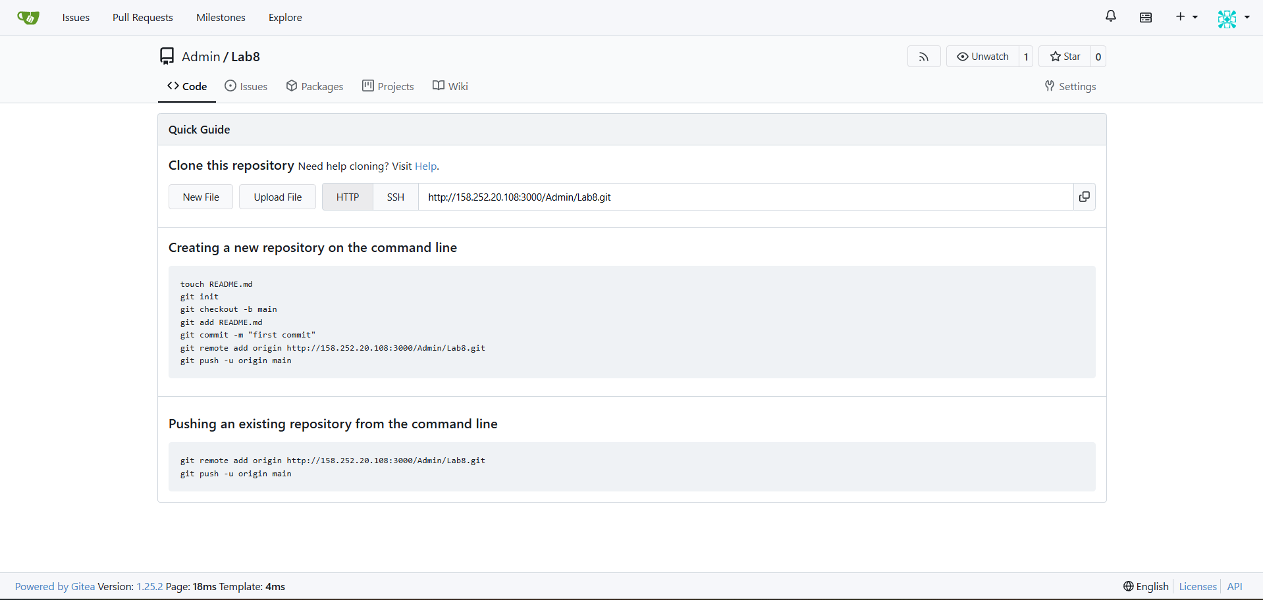

Cleanup — Remove resources to avoid charges
Cleanup steps and required screenshots:
- Terminate the EC2 instance Lab8Machine
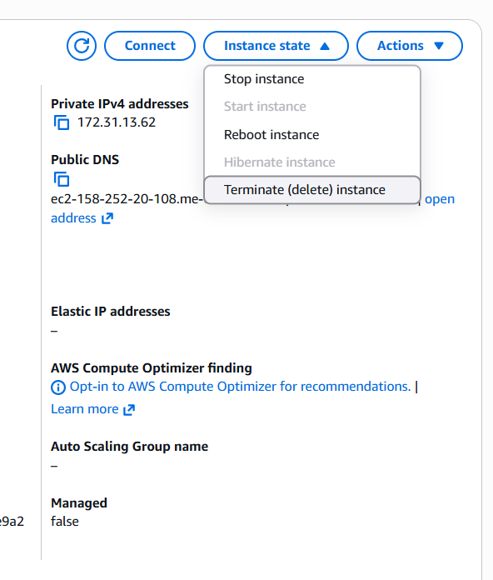
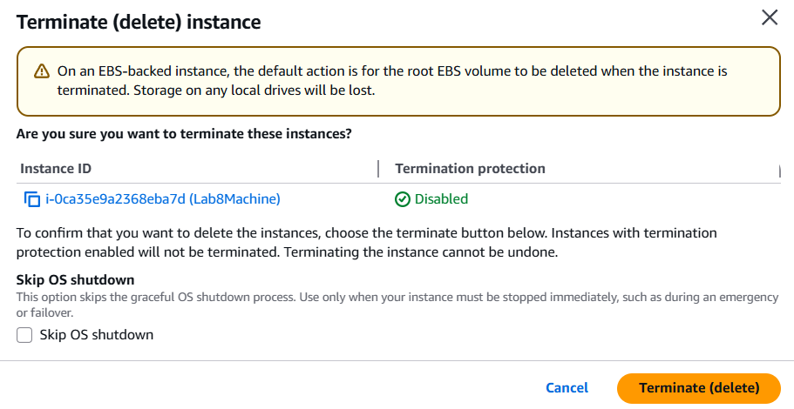
- Delete associated EBS volumes and snapshots (if any).
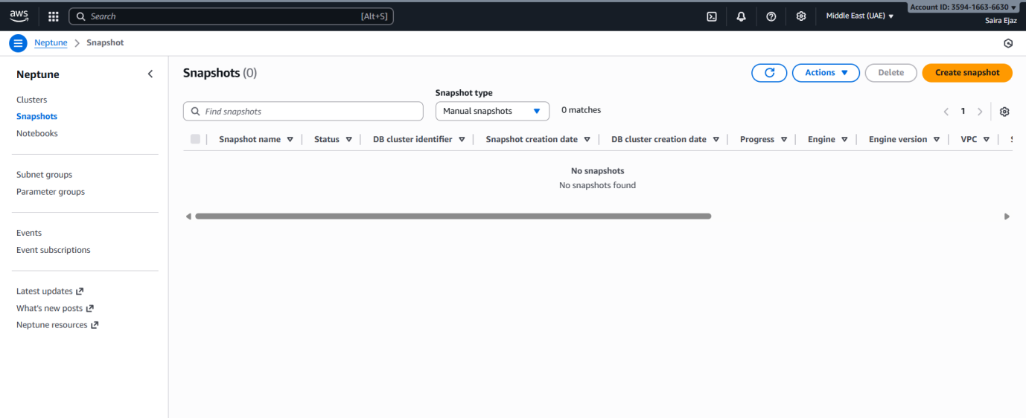

- Delete security group Lab8SecurityGroup and key pair Lab8Key from the EC2 console (after instances terminated).
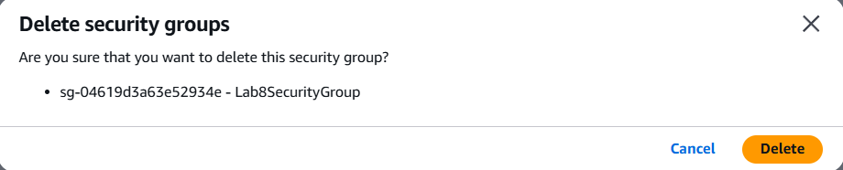
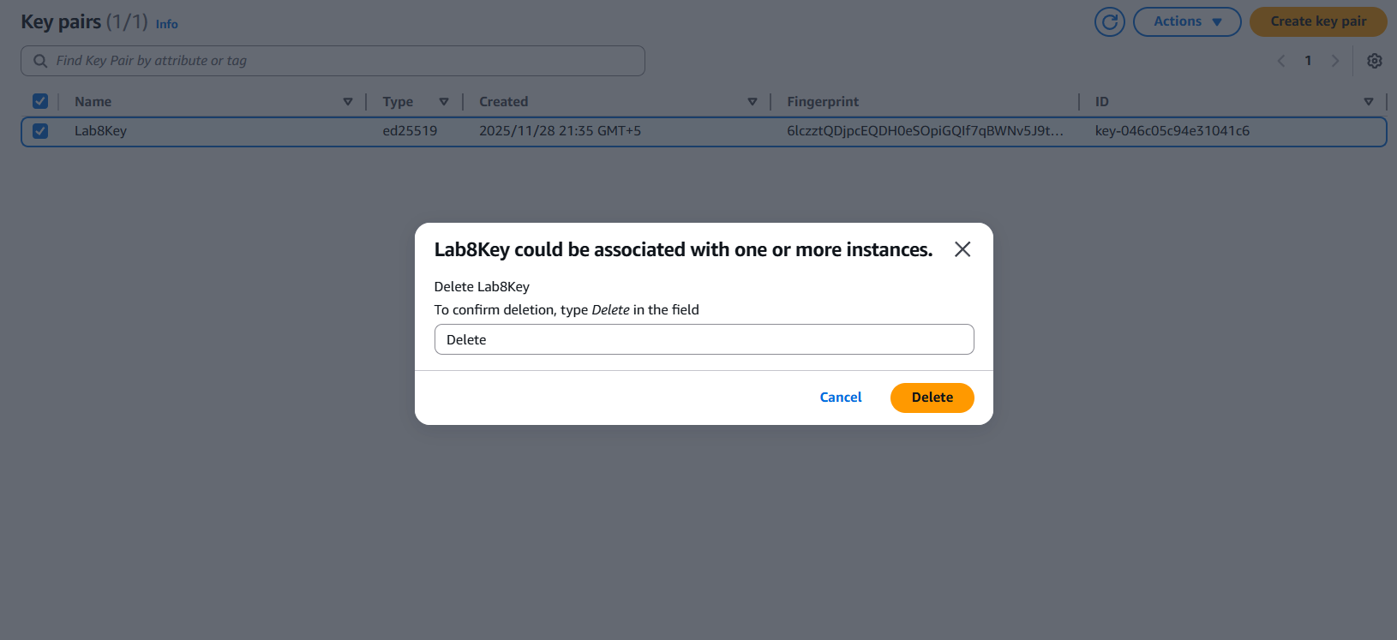
- Delete IAM users Lab8User and any access keys.
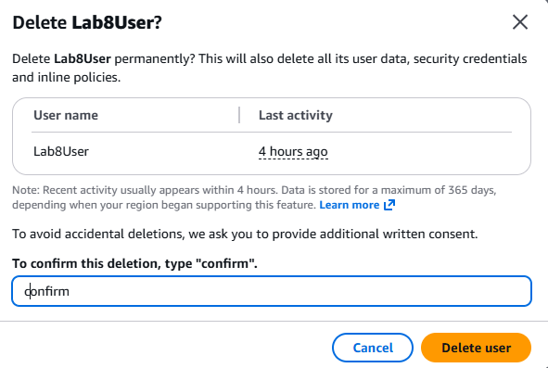
- Final cleanup summary (show billing or resource groups with no active resources if possible).
